Generic Button Mapping

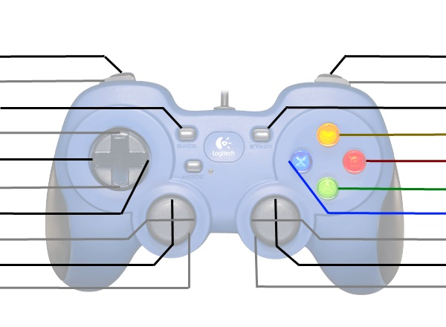

#

#

#

POV Up

POV Left

POV Down

POV Right

X Axis

Y Axis

#

#

#

#

#

#

#

#

Z Axis

Z Rotation

#